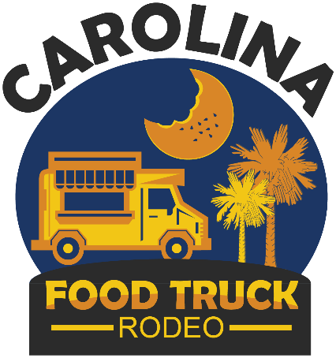

Friday: 5pm-10pm
Saturday: 11am-9pm
Sunday: 11am-9pm

June 26-28, 2020
Florence Center

GENERAL INFORMATION

The Florence Center is pleased to announce the Carolina Food Truck Rodeo on Friday, June 26 through Sunday, June 28, 2020. The Food Truck Rodeo will include a select number of specialty food trucks, a beer garden featuring local and craft beers, a fun kids-zone, popular local musical entertainment, and other business and craft vendors. The Carolina Food Truck Rodeo will be held in the upper west parking lot of the newly expanded Florence Center located at 3300 W. Radio Drive in Florence, SC.

Applications can be mailed or emailed to the Florence Center and will be reviewed on a first come-first served basis. When the maximum number of food trucks are accepted, the application process will be closed. A limited number of food trucks selling similar items will be selected. Vendors are expected to comply with all local and state guidelines and regulations, i.e., the City of Florence Fire Department, City of Florence Police Department, South Carolina DHEC, and the South Carolina Department of Revenue. Applications should include the South Carolina business license number on the application if one is possessed.

- A vendor deposit of at least 50% of the calculated vendor fee must be included with the submitted vendor application. The balance will be due by June 5, 2020. Should the vendor application not be accepted, the credit card will not be processed or check deposited. It will be immediately returned.
- Food Trucks are limited to selling eight (8) items for the vendor fee of $450.00 (beverages are not included in this number) Additional items can be sold for $10.00 per item.
- Vendors are expected to provide their own power/electricity. In some cases, very limited electricity will be available. Water will be provided at a central water source.
- Trash and garbage will be properly bagged and placed behind the vendor operation. It will be collected and properly disposed of by Florence Center operations.
- Vendors must provide their own tents, chairs, tables, electric cords, etc. needed for their operation. A tent with tables and chairs will be provided in a central area by the Florence Center for patrons to sit and eat their food and drink. Tents must be weighted. No stakes are allowed.
- Professional tents are available for rent. They will be installed on Friday morning as soon as the vendor is set up. The tent cost is $150.00 per 10’ x 10’ tent. Side walls are available for an additional $1.50 per foot.
- A current photograph of the vendor set up is required for all food vendors.
- Pepsi products are the only brand of soft drinks permitted for sale.
- For additional information or questions, please call (843) 385-3180.

www.carolinafoodtruck.com

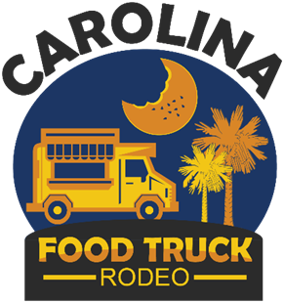

Friday: 5pm-10pm
Saturday: 11am-9pm
Sunday: 11am-9pm
June 26-28, 2020
Florence Center

BUSINESS NAME__________________________________________________________
CONTACT NAME__________________________________________________________
Address_________________________________________________________________
_________________________________________________________________
Email__________________________________Phone(s)__________________________
State of SC Retail License No.________________________________________________

List of food items proposed for sale. All items must be listed:
_______________________ _______________________
_______________________ _______________________
_______________________ _______________________
_______________________ _______________________

VENDOR RATES:

Food Truck – (10’ x 20’) $450.00
Food Vendor – Non- Food Truck (10’ x 10’) $350.00
Business/Commercial Vendor (10’ x 10’) $275.00
Crafter/Handmade (10’ x 10’) $175.00

TOTAL VENDOR FEE: _____________
DEPOSIT PAID W/APPLICATION _____________
BALANCE DUE: June 5, 2020 _____________
Please list other festivals in which you have participated within the past year

Festival Reference Name
__________________________ ______________________________

__________________________ ______________________________

__________________________ ______________________________

__________________________ ______________________________

__________________________ ______________________________

APPLICATIONS MUST BE RECEIVED NO LATER THAN JUNE 5, 2020

Mail to: Florence Center
ATTN: Carolina Food Truck Rodeo
3300 W. Radio Drive
Florence SC 29501

Email to: manager@florencefair.com

Make payable to: Florence Center

Carolina Food Truck Rodeo
Phone: (843) 385-3180
manager@florencefair.com

